V2.1 2022-June-14

* The pin component was removed due to feedback provided by users that the inconsistency in gluing the pin into the slot on the button resulted in unreliable button presses.
* This was replaced with a new button file that features a raised center portion instead of a pin. See picture below.
* Documentation was updated to include this change and remove the pins.
* Design files were updated to remove the pin and add the new button.

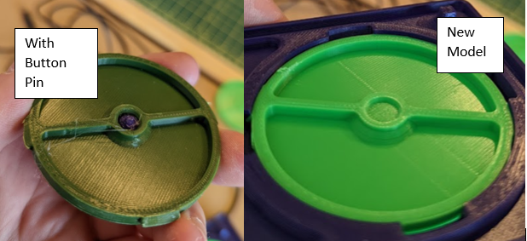

V2.0 2020-Dec-12

* Redesigned top and bottom for 3d printing; incorporated modular buttons and divider
* Redesigned for two mono cables instead of single stereo cable
* Foam-tape joint replaced with 3D printed snap fit hinge

V1.0 2019-Aug-23

* Initial Release
* 3D printable version of AbleNet Rocker